Code Review: I2304139
Reviewer: James Wood
Date: May 12th, 2023
Bugs
Preventative Action/Safety
- Not sure exactly where to put this, as I’m not 100% sure it’s an issue but, it looks like the StdCost field of the Summary report is pulling from the ActualCost of the InventoryItem, whereas the Detail report is pulling the TotalStdCost from the ItemSpec.StdCost field.
- Following from the above point: I’m not sure if you’ve tried, but as Robin noted, it might be best to just use the Detail report query as the nested SELECT query in the Summary query, and just do the necessary grouping outside. This will ensure consistency between the two reports, which, by the sounds of it, only differ by the Location grouping, and some fields. Ensuring that both reports that should be nearly identical are in fact nearly identical, will make future work and review that much easier.
Design/Architecture (Duplication, appropriate project, namespaces, maintainability)
Data Model(Naming, good design, needs index?)
Performance (Minimize DB hits, excessive loops, queries, scalable)
UI(Alignment, naming, standardization)
Error Handling(Behind events, appropriate parameter checking)
Cleanup (Dispose code, remove handlers, large data objects)
Readability (Well-named variables, methods, clear algorithm, is it understandable)
- Nit: While I personally prefer UPPER CASE keywords when writing SQL, since we do not have a standard for it, I will not bemoan that choice. But I will say that a query should remain consistent, one way or the other. I would also recommend using mixed case/letter case for DB objects, as well as qualifying the initial specification of the table with “dbo.” Any further references to the table do not need the qualifier.
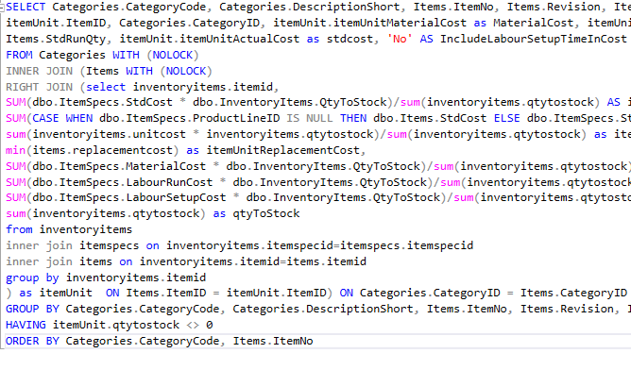
Comments (Useful, explains why rather than how)
Message Boxes (Grammar, spelling, captions, appropriate icons)
Ticket Management(Release Branch?, Testing Notes)
Extras
- It looks like both the Development and Release queries for this report are the same, and different than the currently released query, which tells me that this report change is currently in Testing. However, the ticket was not marked as In Release Branch and the Due Date is end of June, so as it stands it will be released without any QA review.

